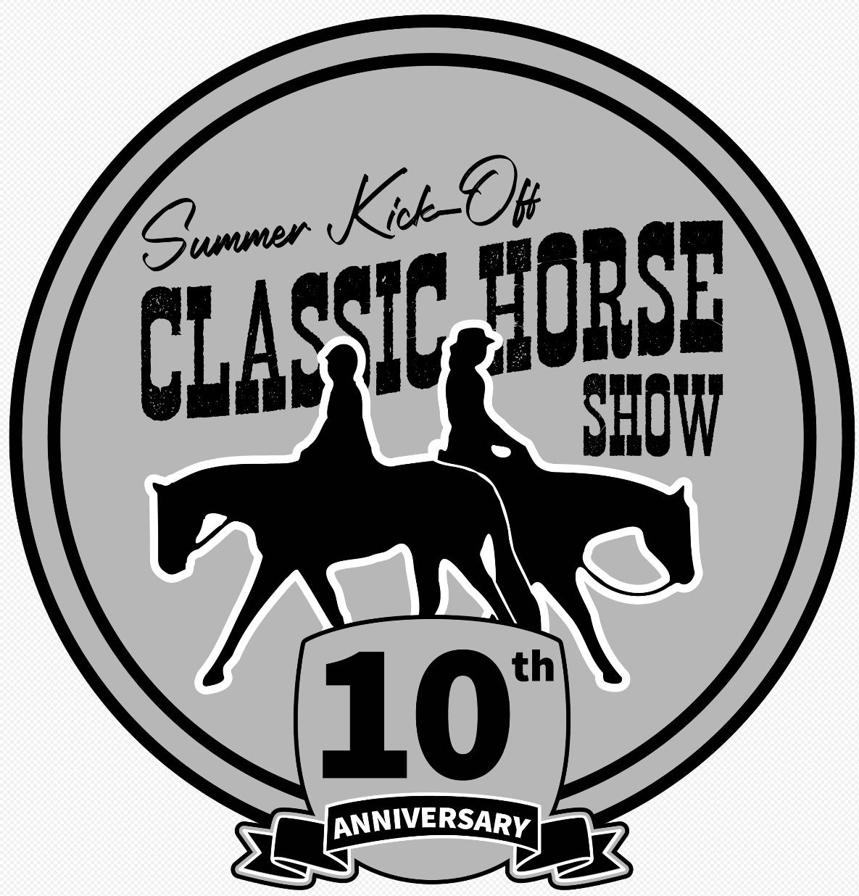 **2025 Summer Kick-Off Classic**

**Horse Show Series**

**Sponsor Form**

Dear Friend:

The Genesee County Agricultural Society and the Summer Kick-Off Classic Horse Show Committee will hold our 10th year of our open horse shows series on May 3rd & 4th, June 14th & 15th  July 25th & 26th, August 23th & 24th, at the Genesee County Fairgrounds Route 5, Batavia, New York. This is a fund-raising event; all proceeds will be used to enhance our horse show area development efforts at the Genesee County Fairgrounds.

Your generous support of our program through sponsorship of a class or high point award would be greatly appreciated. In return for your sponsorship, we will announce your name and/or your company’s name during the class and include it in our show program that will be distributed to all attendees during the event. Businesses will be recognized on our "Summer Kick Off Classic” Facebook page as well.

The levels of sponsorship are per show:

Class Sponsor: $30 – Facebook mention, announcement during your sponsored class(es) and listing in program.

End of Weekend Hi Point Division Sponsor: $125 – Facebook mention, announcement during your division award(s)

Series Weekend Sponsor: $200 - Facebook mention, announcement during your series championship award(s), 2x2 banner displayed

Series Sponsor: $300 – Facebook mention, announcement throughout 8 days of event, 2 ft x 2 ft banner displayed during all the show weekends.

All Shows Event Sponsor: $500 - Facebook mention, announcement throughout 8 days of event, full page ad in program and a 2 ft x 4 ft banner displayed during all the show weekends. Business name added to leather award jackets

We appreciate your support of our development efforts!

Summer Kick Off Horse Show Committee

Email: Summerkickoffshow5@gmail.com

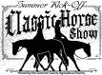

**Summer Kickoff Classic Horse Show Series**

**Sponsor Form**

Sponsor Name:__________________________________________

Address:_____________________________________________________

City:____________________State:_________Zip Code:___________

Phone Number:____________________ Email:_____________________

Number of Classes Sponsored:______x $30 =_____

Number of Day End High Points Sponsored: x:______ $125 =_____

Number of Series Championships Sponsored: x:_____ $200 =____

Number of 4-day event sponsorship ($250) x:______ $300 =_____

Number of All show event sponsor ($500) x:________ $500 =____

**Total Enclosed:_________**  Would you like a receipt emailed to you? ___

**Make Checks Payable to Genesee County Agricultural Society or GCAS**

*Write Summer Kick Off Classic on Memo Line.*

Please include a business card or advertisement if you would like it included in our program or email your high-resolution ad

to suzy.duyssen@gmail.com with subject line SUMMER KICK OFF CLASSIC AD.

**Please Mail this form with check to: Summer Kick Off Classic**

c/o: Genesee Co Agricultural Society, PO Box 359 Batavia, NY 14021-0355 Or Email this form back to us and pay by PayPal

payment@gcfair.com